Claims Adjudication - Frontend Architecture
Author: Siva Bandi Date: 6th Aug 2026

Introduction
Claims Adjudication is a web app for processing insurance claims. It has two parts. The first is a work queue that lists 20,000+ claims. The second is a workspace where adjusters open and work on the documents attached to each claim. Documents can be up to 1 GB. This is a rebuild of a legacy system.

Key Decisions
Landing page data grid
- Sorting, pagination, RBAC filtering all done on server side not on client side.
- Cursor based pagination (with virtualization) instead of infinite scroll.
- Approximate row counts for large result sets to avoid expensive COUNT(*) on every keystroke
- Row actions Edit, Delete, and Assign are available per row and each is RBAC-gated.
- Assign updates optimistically, Delete and Edit wait for server confirmation.
Role-based access (RBAC)
- Backend computes permissions per record and every row carries server-computed permission flags
- There are three outcomes for each action. It is hidden when the role never has that permission. It is disabled with a short reason when it is denied on this specific record. It is allowed when the user has permission.
- Row-level visibility filtered server-side before pagination so that client never receives unauthorized records
- Mutating endpoints re-check permissions server-side regardless of what the UI sent
Row → document loading
- Prefetch document metadata on hover, not on click, so that transitions feel instant
- Workspace bundle loads lazily, prefetched on hover so it's ready before the click
- Layout skeleton on navigation to avoid blank screen while data is loading.
- URL carries filter, page and selected document. This makes the page shareable, survives reload and the back button works
Document workspace
- Client just fetches a few KB of page metadata, never the full file
- Pages loaded on demand via pre-rendered derivatives or HTTP Range requests
- Split/merge/delete under ~25 MB runs in a Web Worker on client side, large files run on server side.
- Every operation publishes a new immutable version to make sure that failed operations leave nothing half-done
- Annotations anchored to page identity, not page number. This ensures they survive splits and renumbering.
- Documents arrive through multiple channels including email, SFTP, and direct upload. They can be structured or unstructured. When a document arrives an ingest pipeline linearises it, builds a page index, generates thumbnails, and runs OCR on scanned pages. This happens before any adjuster opens the document.
- Edit covers page-level changes such as rotating, reordering, and deleting pages, plus adding comments and annotations. Editing the actual content inside a page is out of scope.
Performance
- To avoid unnecessary rerenders rows are memoised with stable callback references.
- Fixed column widths, CSS transform positioning so that no layout recalculation per scroll frame is needed.
- Filter input debounced with useDeferredValue to ensure typing doesn't queue up server requests
- Sliding page window (~12 pages max) with explicit canvas eviction to release GPU memory
Scalability
- Keyset pagination stays fast as record volume grows so that there is no OFFSET scan cost
- Per-page derivatives served from CDN making sure viewer performance is independent of file size
- Server-side operations for large documents so that client memory cost stays flat regardless of file size
- Multiple users can work on different claims at the same time without affecting each other. If two adjusters open the same document, ETag versioning makes sure neither one silently overwrites the other.
UX
- Previous page stays visible while next page loads to avoid blank flash between pages
- SSE for long-running operations, live progress and cancel. This avoids unnecessary spinner/loading screens
- Long-running tasks can be cancelled while in progress. If a task fails, the user can retry it without starting over. The UI shows enough context to make it clear what is being retried and why it failed.
- Error states have recovery paths. Retry on transient failures, clear messaging on permanent ones
Reliability
- Immutable versioning with ETag concurrency. Two adjusters can't silently overwrite each other
- Failed merge is atomic. Either all inputs succeed or nothing changes, no partial state visible
- When a long-running operation fails partway through, the original document is not changed. The user gets a clear message about what failed and can retry. Partial failures are reported with enough detail to understand what went wrong.

Architecture
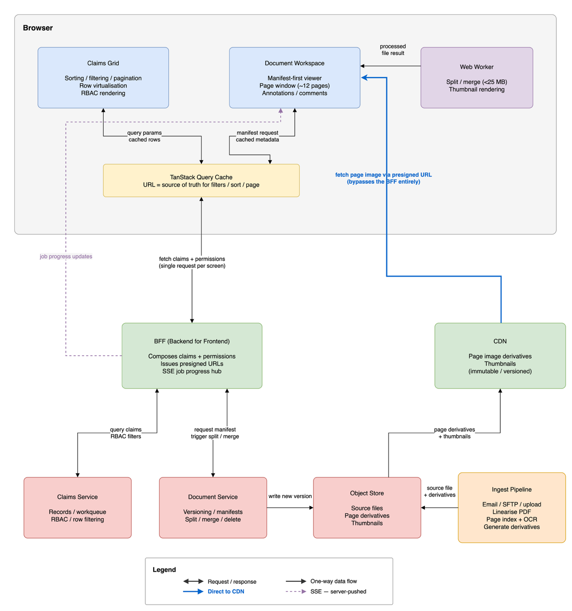

The app has two feature areas, the claims work queue and the document workspace. They share only a claim ID through the URL. The grid has no knowledge of the workspace, and the workspace does not read grid state. This means each can be built, tested, and loaded independently.
Component boundaries: Each feature area owns its own components, API calls, and local state. Things that are shared across both, like buttons, session data, and permission flags, live in a separate shared layer. The workspace code only downloads when the user navigates to it.
State management: Different types of state live in different places. Filter, sort, and page state lives in the URL so any view is shareable and survives a page reload. Server data like claims and documents goes through TanStack Query, which handles caching, deduplication, and retry. Local UI state like whether a dropdown is open stays in the component that owns it. The document operation queue uses a reducer because it is a proper state machine with multiple concurrent jobs driven by server events.
Data fetching and caching: TanStack Query caches responses by URL parameters. The previous page stays cached while the next one loads so there is no blank flash between pages. Document pages are immutable per version so they can be cached for a long time and never need to be re-fetched.
Backend API: The design assumes a BFF that returns claims and permissions together in a single response per screen, so the client is not making multiple requests on every load. Every row in the response includes permission flags computed by the server. The ingest pipeline generates page thumbnails and a page index before any adjuster opens a document. The claims endpoint supports cursor pagination.
Where authorization lives: The backend checks permissions on every request. The frontend reads the permission flags it gets back and renders accordingly. Removing all the client-side permission checks would make the app look different but would not change what users are actually allowed to do.
Where validation lives: The client validates input for fast feedback, but the server validates every request as the source of truth and rejects anything invalid regardless of what the client sent. This is the same principle as authorization. The UI is a convenience, the server is the control.
RBAC in the UI: The backend sends a permission flag for each action alongside every row. There are three outcomes. The action is hidden when the role never has that permission. It is disabled with a short reason when it is denied on this specific record. It is allowed when the user has full permission. Row visibility is also filtered server-side before pagination so the client never receives a record the user should not see.
Row to document transition: Document metadata starts fetching when the user hovers over a row, not when they click. By the time they click the data has usually already arrived. The workspace code loads lazily and is prefetched on hover, so it is ready. A layout skeleton appears on navigation so there is no blank screen while data is loading. The URL includes the selected document so the view can be shared and will persist across reloads.
Ingest pipeline: Claims arrive through email, SFTP, portal uploads, and API. Some documents are structured PDFs and some are scanned images. When a document arrives the pipeline linearises it, creates a page-level index with byte ranges, generates thumbnails for the rail, and runs OCR on pages that do not have a text layer. The viewer depends on this pipeline having run before the adjuster opens the document.
Why not SSR: This is a behind-login internal tool, so the usual SSR wins of SEO and fast first paint for anonymous visitors do not apply. The heavy parts, a 20k-row virtualised grid and a large document viewer, are inherently client-side and interactive, so SSR would render an empty shell and the client would fetch the real data anyway. It would also add a server rendering tier to run and secure, and hydration to debug, for almost no benefit. Route-level code splitting, a layout skeleton on navigation, and prefetch on hover give the same perceived speed without that cost.

Performance strategy
All sorting, filtering, and pagination happens on the server. The client only ever holds one page of results at a time.
Rendering 20k+ rows: Rows are memoised with stable callback references so changing a filter does not re-render every visible row. Column widths are fixed numbers so the virtualizer never has to measure the DOM. Row positions use CSS transform so scroll movement stays off the layout thread. Filter input is debounced, so typing does not fire a server request on every keystroke.
Handling large documents: The client never downloads the full file. It first fetches a manifest, which is a small JSON file that describes every page, its dimensions, and its byte range within the source file. Pages are then fetched one by one as the user scrolls, either from pre-rendered image derivatives or via HTTP Range requests. A sliding window keeps about 12 decoded pages in memory at any time. When a page scrolls out of the window its canvas element is explicitly destroyed to release GPU memory. Without this step a long session on a large document will eventually crash the browser tab.
Document operations: Files under about 25 MB are processed in a Web Worker so the main thread stays responsive. Larger files are processed on the server. Since the bytes are already there, sending an instruction to the server is always going to be faster than downloading a 600 MB file just to manipulate it in the browser.
Long-running operations: When a split or merge is submitted, the API returns 202 Accepted with a job ID straight away. Progress updates come back via Server-Sent Events. The client opens an event stream for the job and receives updates as they happen. Users can cancel at any point. SSE was chosen over WebSocket because progress only flows one way, it runs over plain HTTP, it works through corporate proxies without any extra configuration, and it reconnects on its own if the connection drops.
Code splitting: The workspace bundle, which includes the PDF rendering code, only loads when the user navigates to the workspace. The grid works without it. The bundle is prefetched on row hover so it is usually ready before the user clicks.

Trade-offs
These are the main decisions where there was a genuine choice between approaches and a reason to pick one over the others.
Pagination vs infinite scroll vs virtualization: Infinite scroll was ruled out early. Adjusters need to be able to reference a specific row by page and position for handoffs, audits, and shared links. Infinite scroll also keeps adding DOM nodes without ever releasing them. Full client-side virtualization was ruled out because you still have to fetch all 20k rows first. Server-side pagination with row virtualization inside each page keeps memory bounded and every page deep-linkable.
Client vs server processing: For document operations the approach is straightforward. If the bytes are already on the server, do the work there. For large files this is the only option that actually fits within browser memory limits and is performant. For small files, the Web Worker path is faster because it avoids a round-trip to the server.
Caching: The previous grid page stays cached while the next one loads. This prevents the blank flash that appears when navigating between pages. Document page images are tied to a specific version and never change once generated, so they can be cached at the CDN for a long time without ever needing to be refreshed.
Optimistic vs pessimistic updates: Low-risk and easily reversible actions like assigning a claim update the UI straight away and roll back if the server rejects them. Destructive or multi-step actions like deleting a claim or merging documents wait for the server to confirm before the UI changes. Most users expect this behavior without thinking about it.
Document versioning: Every operation creates a new immutable version of the document rather than overwriting the existing one. This means two adjusters working at the same time cannot silently overwrite each other. If a merge fails, no partial version is ever made visible. Annotations are tied to a stable page identity rather than a page number, so they stay in the right place after a split or renumber.
SSR vs client-side rendering: Went client-side. SSR mainly helps SEO and first paint for anonymous users, and this is a behind-login tool where neither applies. The grid and document viewer are client-side by nature, so SSR adds a rendering tier to run and secure for no real gain.

Accessibility
The data grid needs proper ARIA roles so screen readers can announce row count, column headers, and the current position. Virtualization makes this harder because most rows are not in the DOM at any given time. The row count and row index attributes need to reflect the full logical set, not just what is rendered.
Red and green are the most common form of colour blindness. Every status indicator in the grid uses both a colour and an icon so the meaning is clear without colour.
A rendered PDF page is an image and screen readers cannot read it. The text layer produced by OCR during ingest is what makes the document accessible. Pages without a text layer are flagged clearly in the UI so adjusters know when a document has not been processed yet.
Long-running operations announce their completion through a live region so keyboard users get the same feedback as mouse users.

Security and data privacy
Claims documents hold sensitive medical and personal data, so a few things matter beyond normal RBAC.
Presigned URLs for document pages are short-lived and expire quickly. A leaked URL is useless within minutes.
Document bytes never pass through application logs. Only metadata and IDs are logged, never file contents.
Every access and every mutating operation is recorded for audit. Who viewed a claim, who edited a document, and when.
Access tokens are short-lived and refreshed silently. The frontend never stores long-lived credentials in local storage.

Delivery approach
Since this is a rebuild of the legacy system, the goal is to replace it without disrupting the adjusters who use it every day.
The rebuild would happen incrementally. New routes are added to the new application one at a time. A feature flag or routing layer at the edge sends traffic to the new app for those routes and keeps everything else on the legacy system.
Read-only screens first, then the grid with filtering and RBAC, then the document viewer, then write operations like split and merge. Each phase can be tested and rolled back independently.
Adjusters should not notice a difference during the migration. The design tokens, navigation structure, and core workflows stay consistent across both systems during the transition period.

Backend assumptions
The design assumes a BFF that composes claims and permissions into a single response so the client is not making multiple requests per screen. It also assumes per-record permission flags in every row response, HTTP Range request support on document storage, an ingest pipeline that generates the page index and thumbnails before adjusters open documents, and cursor pagination on the claims endpoint.
If per-record permissions and the ingest pipeline don’t exist yet, those come first. Everything else depends on them.

Tech stack
Framework: React with TypeScript. Component-based, strong typing, and the largest ecosystem for the kind of data-heavy UI this needs.
Build tool: Vite. Fast dev server and build, first-class code splitting for the lazy-loaded document workspace.
Data grid: TanStack Table for the grid model and TanStack Virtual for row virtualisation. Headless, so it fits any design system, and handles large datasets without fighting the framework.
Server state: TanStack Query for caching, deduplication, background refetching, and retry. Removes the need for a global store to hold server data.
Routing and URL state: React Router. Filters, sort, and page live in the URL so any view is shareable and survives a reload.
Document rendering: pdf.js for the viewer, with pages rendered on demand from pre-rendered derivatives or HTTP Range requests.
Background work: Web Workers for client-side split and merge on small files, keeping the main thread responsive.
Styling: CSS custom properties (design tokens) for theming, no runtime styling cost, and easy dark mode support.
Testing: Vitest for unit and logic tests, React Testing Library for components, and MSW to mock the API in both tests and local development.
Long-running jobs: Server-Sent Events for job progress, chosen over WebSockets because progress only flows one way and SSE works through corporate proxies without extra setup.

